Revision date: May 16, 2012

I. Cards for Matter Association Questions (10 cards)

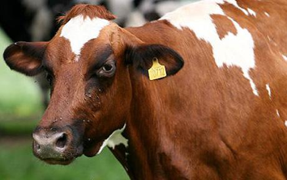 | 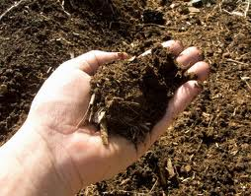 | Oxygen (O₂) | Carbon dioxide (CO₂)
muscles in a cow | Soil | In Air | In Air
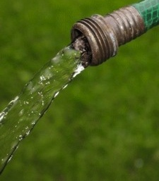 | 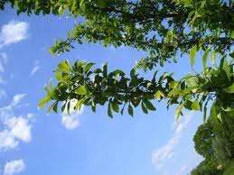 | 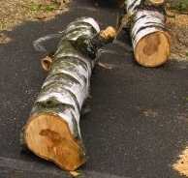 | 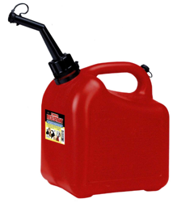
Water (H₂O) | Living Branches | Dead Wood | gasoline
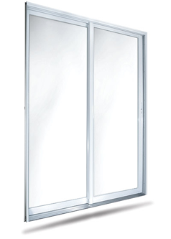 | 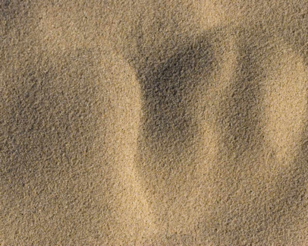
Glass | Sand

III. Inquiry Questions

A. Initial claim card


Plants gain most of their weight from materials that came from the soil.
Plants gain most of their weight from materials that came from the air.
Karen
Mike

B. Follow-up argument cards (2 cards. Use the card for the argument that the student agrees with first.)

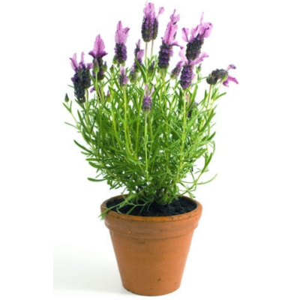
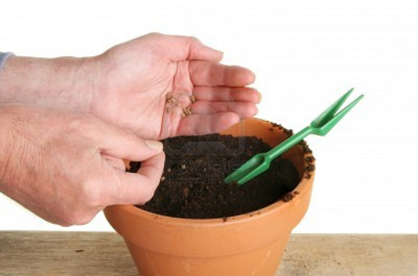
You can grow a big plant in a little pot without a lot of soil.
Seed = 1 g
Soil = 80 g
Soil = 78 g
Plant = 50 g
Seed planting
One year later
Karen
Plants have roots to take up nutrients from the soil to grow.
Plant grown without fertilizer
Plant grown with fertilizer
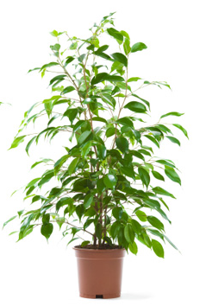

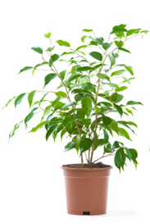
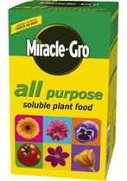
Plant = 50 g
Plant = 65 g
Mike

V. Cards for Cross Process Questions (6 cards)
 | 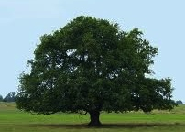 | 
Car running | Tree Growth | Baby girl growth
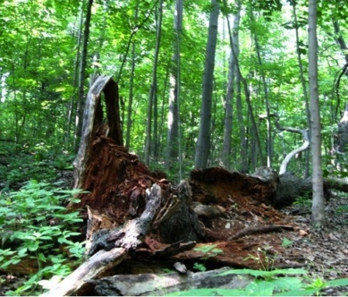 |  | 
Tree Decaying | Flame burning | Girl jumping

VII. Cards for Vocabulary and Plant Structure Questions (2 cards)
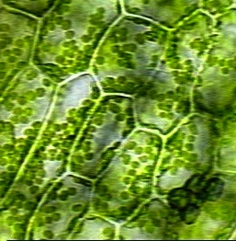 | 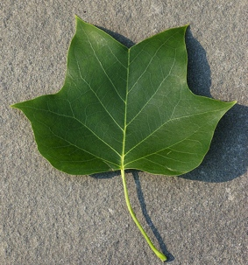
Close-up of a leaf | A leaf
VI. Cards for Ecosphere Questions (1 image)

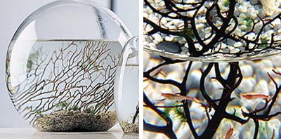

NASA scientists invented the EcoSphere – inside a completely sealed glass container, (there is no opening at the top of the jar!) there are air, water, gravel, (the branch-like thing is just for show) and three living things – algae, shrimp, and bacteria. The shrimp are orange and the algae are green like a plant, you can’t see the bacteria.) Usually, these three living things can stay alive in the container for two or three years until the shrimp become too old to live. The picture above shows an EcoSphere and it’s inside parts. The EcoSphere is a closed ecosystem and has no exchange of matter with the outside environment.

